user interface prototype

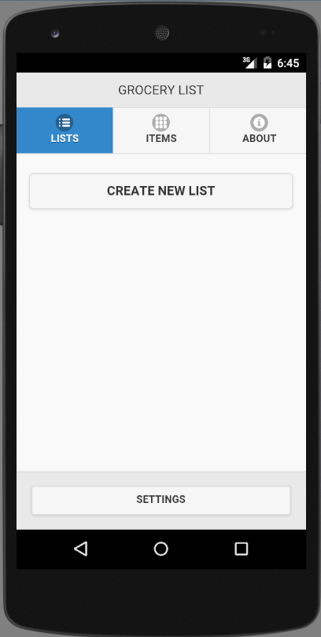

Figure : Screen 1- View Grocery Lists